Chapter 16 The 20's, 30's, 40's, WWII 1920-1947

1. Art Deco- Lauren Shumway

Art deco was an art movement known for its modern, clean, and streamlined shapes and its clear influences from ancient Egyptian, Native American, African, and southern Asian influences. The movement was popular from before World War I until the Great Depression. Unlike Art Nouveau's abundance of curves and details, art deco primarily lines with little to no detail. Art deco is seen in fashion by the work of Poiret, Worth, and Patou. It is also seen in the jewelry from the time of geometric shape.

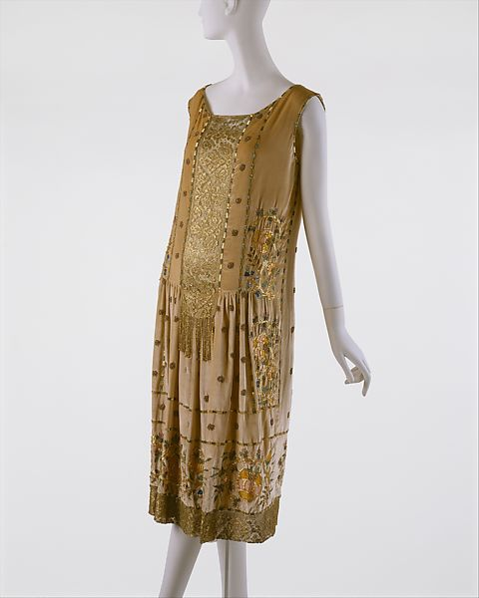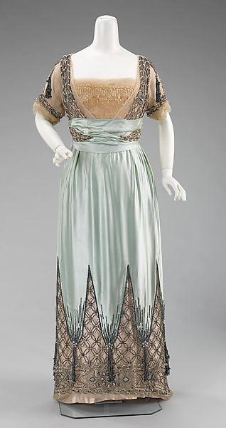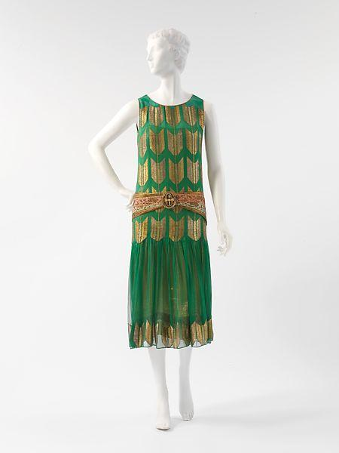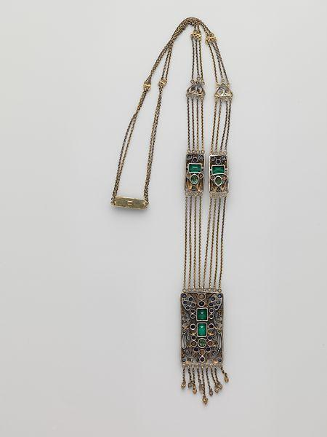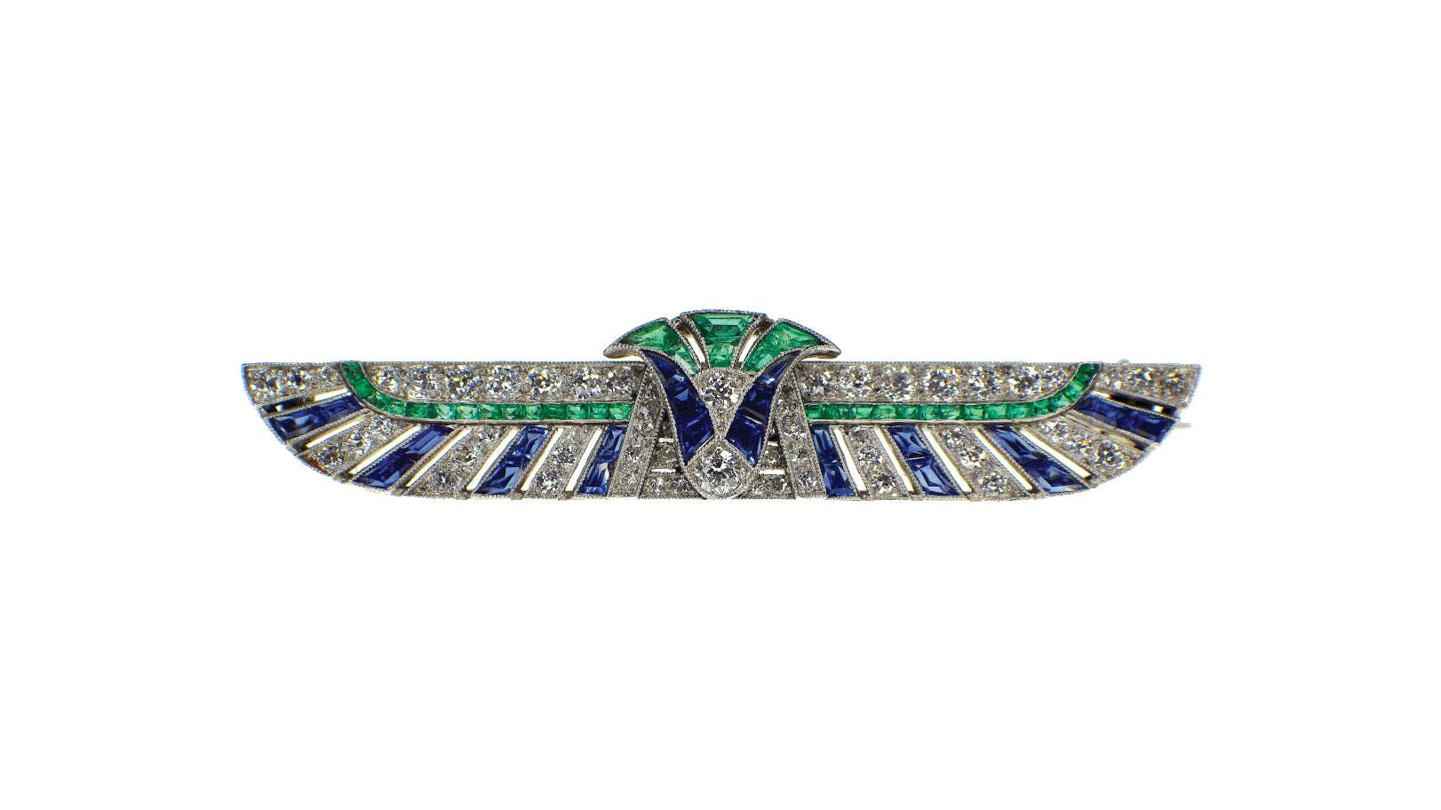

The Book

https://www.theartstory.org/movement/art-deco/history-and-concepts/

https://en.wikipedia.org/wiki/Art_Deco#Textiles_and_fashion

1. The Chrysler Building- jamie Rakes

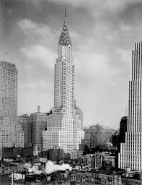

The Chrysler Building was built between 1928 and 1930. It was designed by William van Allen and was known during the time to be the Art Deco building. Walter p. Chrysler is who commissioned the building. The building's slick designs were modern for the time 1920. Not only was the building the Art Deco jewel of new years during the 1920s. But the building was also inspired by the Chrysler car as well. It was the tallest building until 1931 when the Empire State Building was built

<https://www.britannica.com/topic/Chrysler-Building>

<https://www.jamesmaherphotography.com/new-york-historical-articles/chrysler-building/>

Book pg

L-85 Regulations- Abbie Burns

This was a restriction that was set on the quantity of cloth that could be used in clothes. This restriction made it so men pleats, ruffles and patch pockets. This restriction changed the rest of fashion for women. When times became scarier the clothes became more modest. 

Sources

Book: pg:451

<https://www.sarahsundin.com/make-it-do-clothing-restrictions-in-world-war-ii/>

http://www.regulationl85.com/info

1. Artificial Silk/Rayon - Abby Fluckiger

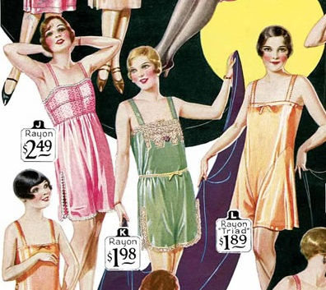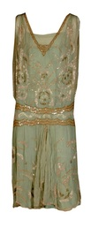

Up until the 1930s, the only fabric widely available was natural fiber-based fabric: wool, cotton, linen, and silk. A type of semi-synthetic cellulose fabric was invented as early as the 1880s, but not manufactured in the United States until around 1911; the synthetic fabric evolved into viscose and then cellulose acetate, and then what we now know as acetate rayon, which was called artificial silk until 1924, when the name “rayon” was coined by the National Retail Dry Goods Association. Rayon entered popular usage in the 1920s, and has been popular since.

Sources:

Textbook page 464

<https://www.britannica.com/technology/rayon-textile-fibre>

<http://www.museumtextiles.com/blog/category/rayon>

1. Barrymore collar & California Collar- Andrea Lazaro

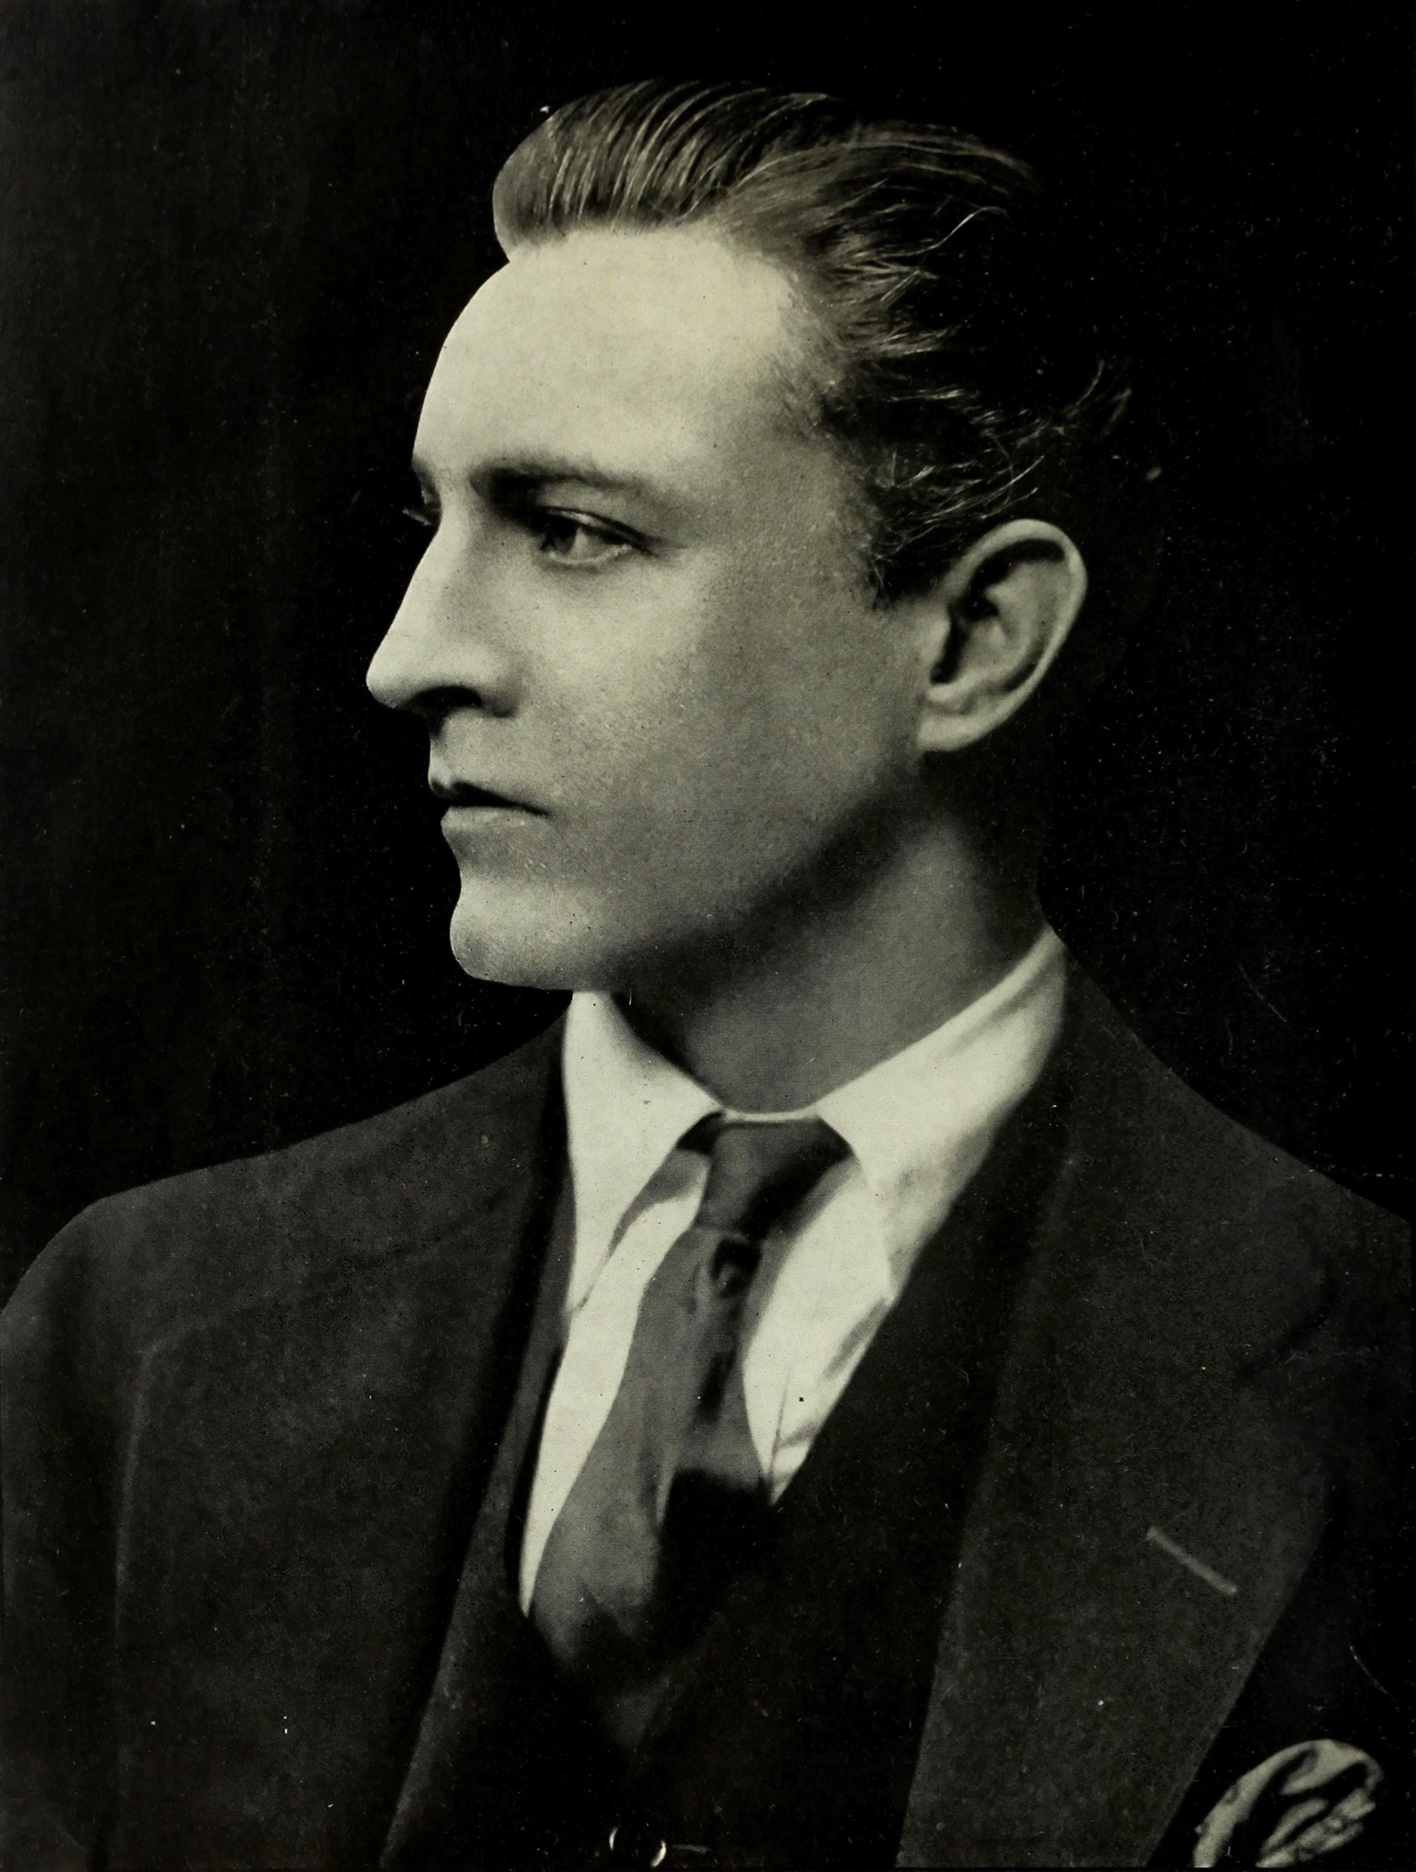

A Barrymore collar was a turnover shirt collar with long points. It was named after actor John Barrymore who used to wear this type of collar. This type of collar began in between the 20s and 30s and came back in fashion during the 70s. Barrymore collars were normally wear on dress shirts, and with a bow or a tie. California collars were similar to Barrymore collars, but they had shorter, wider points.

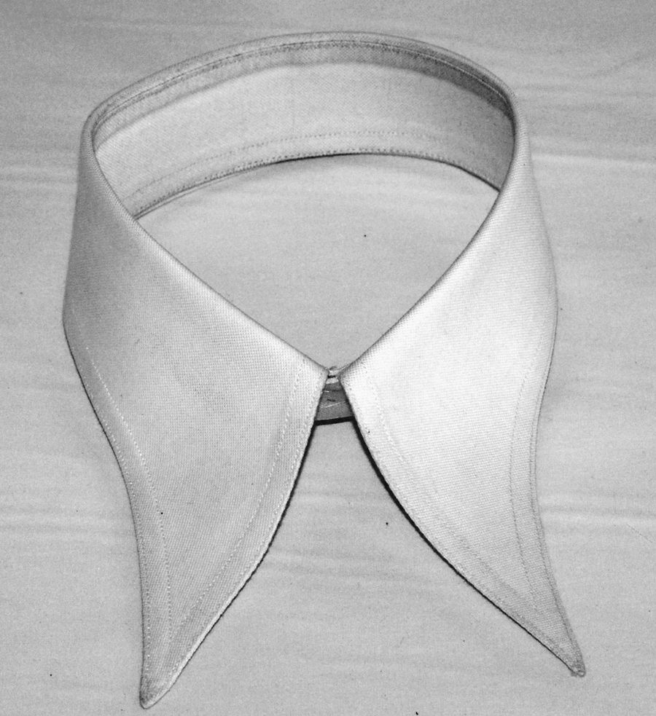

Sources:

Survey of Historic Costume pages 481-482

<https://en.wikipedia.org/wiki/Collar_(clothing)>

<https://www.wholesaleclearance.co.uk/blog/reference-guide-to-types-of-collars/>

1. Bob Chambre de Syndicale -
2. Chukka Boots- Jessica Fraser

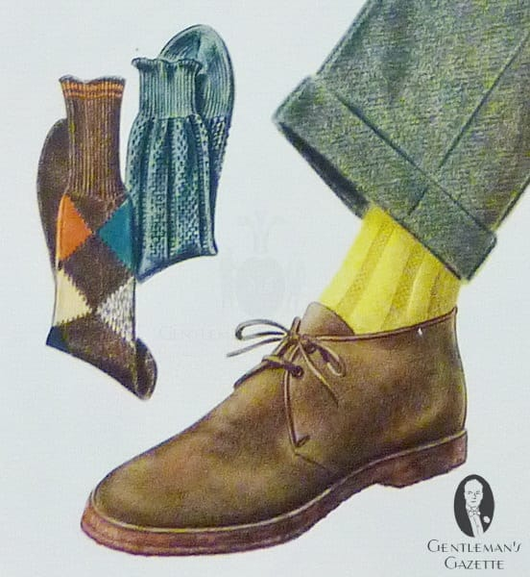

Ankle boots that closed with laces. They were made of leather and laced all the way up to the ankle. It also had a rounded toe. It had three eye litts on each side of the shoe to hold the lace. The sole of the shoe was very thin and made of leather. These shoes were worn by the British army right before WW2 and became a hit in the 1930's and 40's. They brought style and comfort.

Sources:

The Book (pg. 487)

<https://www.gentlemansgazette.com/the-chukka-boots-guide/>

[(Links to an external site.)](https://www.gentlemansgazette.com/the-chukka-boots-guide/)

<http://www.catwalkyourself.com/fashion-news/the-history-of-chukka-boots/>

[(Links to an external site.)](http://www.catwalkyourself.com/fashion-news/the-history-of-chukka-boots/)

1. Clasp Locker - Kimberly Tesam Moita

The Clasp locker is credited to by Whitcomb L. Judson, and actually didn’t get called the “zipper” until later. It was originally designed for fastening boots up since it was difficult to lace them up constantly. “But, it was originally an idea thought up by the inventor of the sewing machine Elias Howe Jr. as an ‘Automatic, Continuous Clothing Closure.’ It didn't go much further beyond that, though. Perhaps it was the success of the sewing machine that caused Elias not to pursue marketing his clothing closure system.” (*Thought Co.)* So it was patented 45 years after the sewing machine. “The B. F. Goodrich company later in 1923 installed these fasteners in their rubber galoshes, calling the new design ‘Zippers.’ This then became the name of the fastener itself.” (*wikipedia)* The Clap locker itself, was like a bunch of interweaving hooks that when the fastener passed over it would help the other hook to each other as it moved up and unhooked as it moved down, helping to fasten the opening.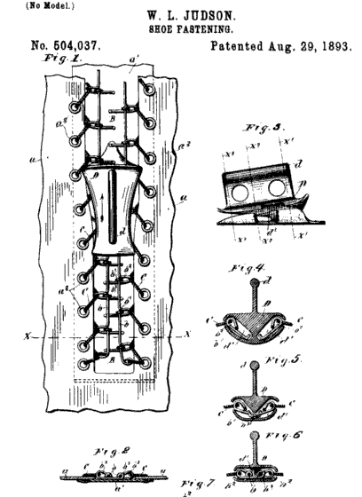

<https://www.thoughtco.com/history-of-the-zipper-4066245>

<https://en.wikipedia.org/wiki/Whitcomb_L._Judson>

<https://patents.google.com/patent/US504038A/en>

1. Cloche Hat - Marisa Bone

The Cloche hat is a bell shaped hat for women that was invented by milliner Caroling Reboux. (A milliner is a person who makes or sells women's hats.) They were especially popular in 1922 to 1933 The name "Cloche" means the word "Bell." It had more of a snug fit to show off the short bobs and hairdos. It would be worn so low over the eyebrows at times that women walked with their chins up and eyes cast down "Gibson girl anyone?" It created an air of confidence and allure for the wearer. Personally, I believe that the cloche hat could have been the earlier version of the bucket hat we all know and love today!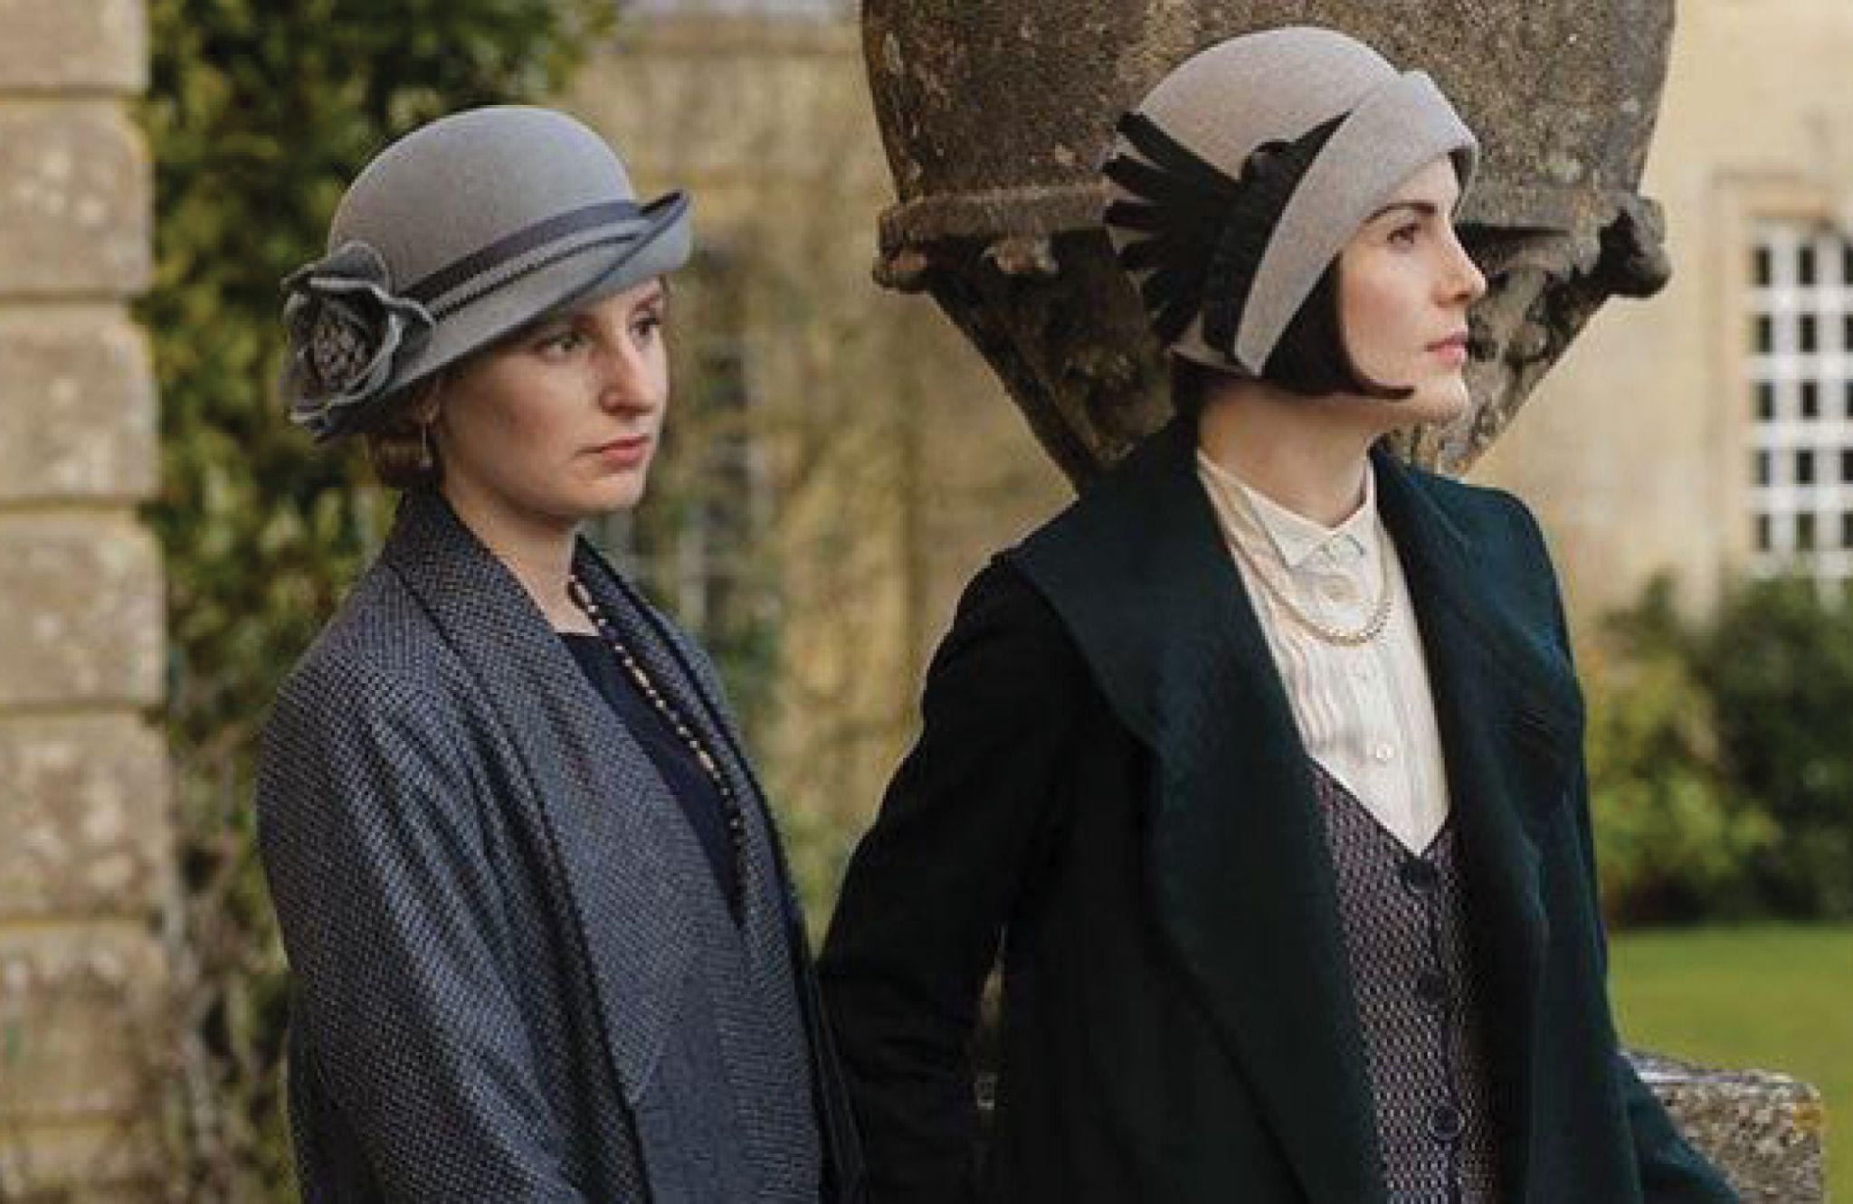

[Source 1](https://en.wikipedia.org/wiki/Cloche_hat)  [Source 2](https://startupfashion.com/fashion-archives-history-cloche-hat/)

Page 466 and 468

1. Clutch Coat -Abigail Storrer

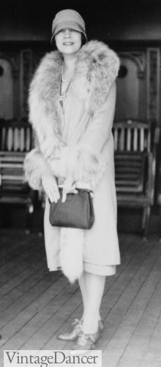

Clutch coats were coats that had to be held closed by your hand, hence the word clutch. They had no buttons or other closure to keep them shut. Because of this their small purses were also held under the arm. With no fastenings to hold coats closed it was also a great way to show off your dress. Fur was also very popular at this time and many coats were trimmed or decorated with it. Especially fur collars on the coats.

Book Pg, 466

<https://fidmmuseum.org/2014/09/fall-dressing-coats-and-jackets.html>

<https://vintagedancer.com/1920s/womens-coats-of-the-1920s/>

1. Dishrag Shirt - Hannah Ferreira
2. Eisenhower Jacket & Battle Jacket-Aniston Hardin
3. The Guards Coat- Zaya Weight

The guards’ coat was a dark blue overcoat originating in the 1930s. It was based on the coat that was worn by English Officers of the Guard. It was double breasted with wide lapels. inverted pleating in the back, & a half belt.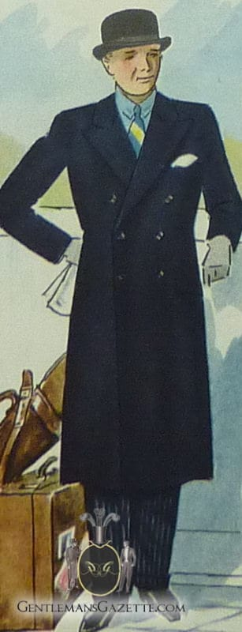

**Sources:**

Survey of Historic Costume

<https://en.wikipedia.org/wiki/Guards_Coat>

1. Flappers Hookless Fasteners & Zipper -Amanda Taylor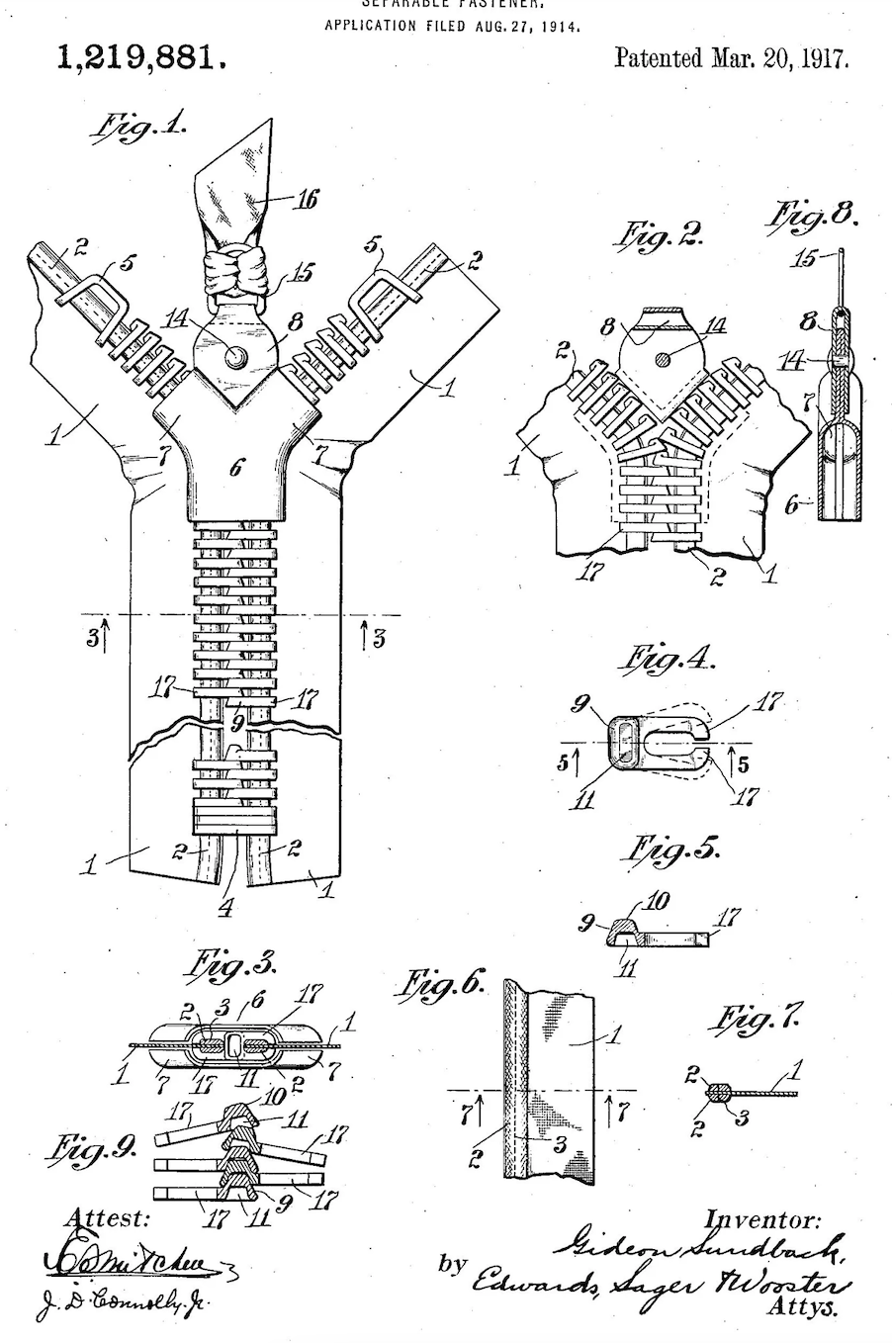

The hookless fasteners and zippers were revolutionary as they helped people get in and out of their clothes much more easily. The zipper was invented by Whitcomb L Judson in 1891 in Chicago. The first version of the zipper was called a clasp locker. Later another man, Gideon Sundback improved the device and called it a hookless fastener. These were used in corsets, gloves, sleeping bags, money belts, and more. B.F. Goodrich continued to expand on this idea and coined the term zipper. By the mid 30’s everyone knew what zippers were but they were not commonly used. Eventually, following the lead of the English Prince of Wales and his brother the Duke of York, zippers became a more common fashion in mens trousers.

Textbook pg. 455

https://witness2fashion.wordpress.com/tag/hookless-slide-fastener/

https://www.history.com/news/world-war-i-inventions-pilates-drones-kleenex

1. Lacoste Knit Shirt - Jensen Stenquist

In Boston in 1923, his captain promised to buy him a crocodile leather suitcase he had been admiring in a shop window if he won his next match. René lost, but in tribute to his tenacity on the court and in reference to this unusual bet, the American press christened him “the crocodile.” In 1933, he brought a revolution to the courts in the form of a flexible, lightweight polo shirt in “petit piqué” cotton, flying in the face of the regular shirts imposed on tennis players. He founded Lacoste with André Gillier, which became the first brand to feature a logo on its clothing. 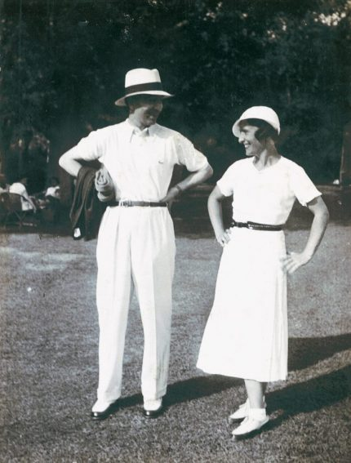

<https://corporate.lacoste.com/our-history/>

<https://www.townandcountrymag.com/style/fashion-trends/a20200495/lacoste-history/>

The Book

1. Lastex - Hannah Ferreira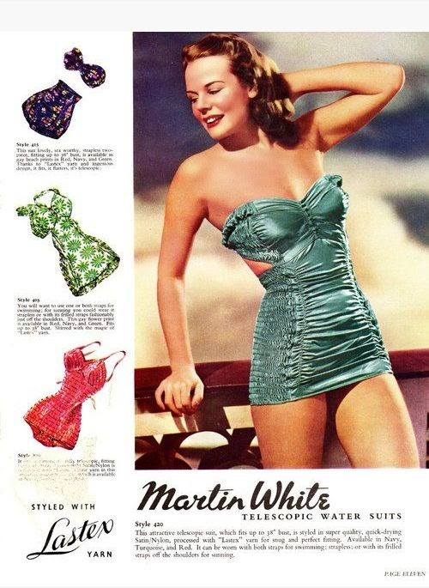

Used to make swimsuits in the 1930’s. Lastex is a fabric made from yarns with a rubber core covered by another fiber. Was used to make swimsuits that had stretch and were more form fitting and wrinkly free than other fabrics. This made millions of girls very very happy as the lastex was a great alternative to previously swim fabrics that were very droopy, like cotton and wool.

<https://forums.vintagefashionguild.org/threads/1930s-1940s-lastex-swimsuit.52787/>

Book pg. 478

<https://wearinghistoryblog.com/2010/06/make-a-splash-bathing-suits-1938-and-lastex/>

1. Bathing Suits - Aubrey Reidhead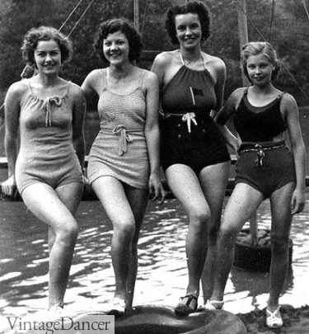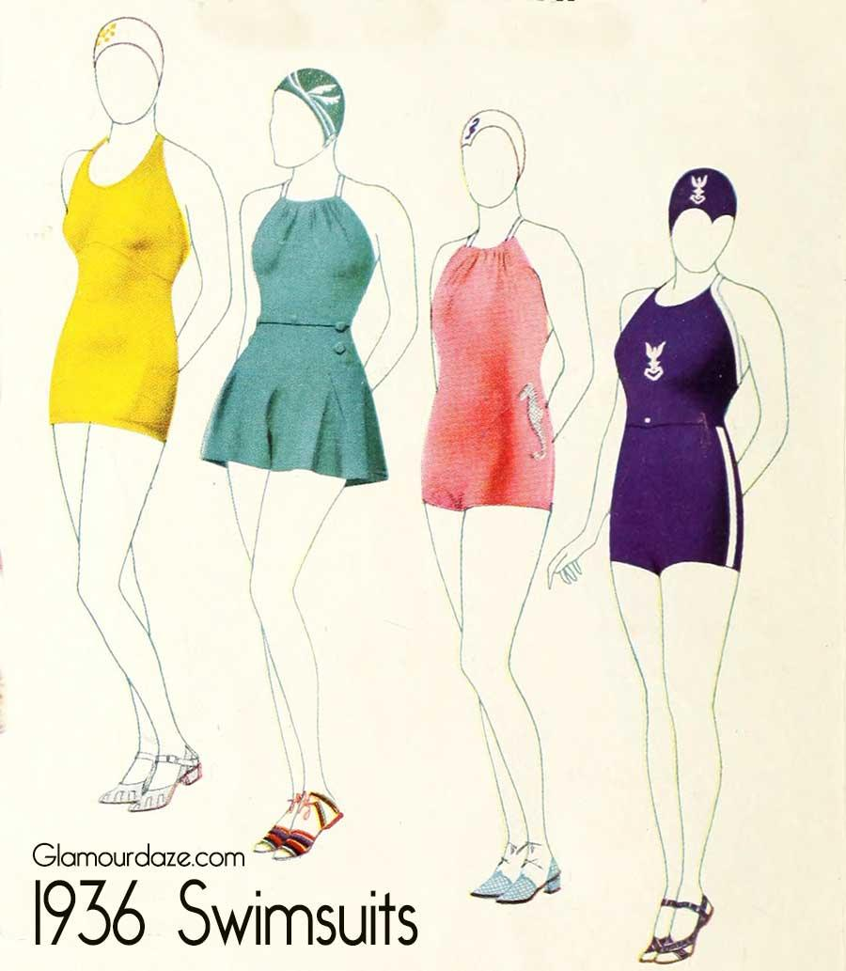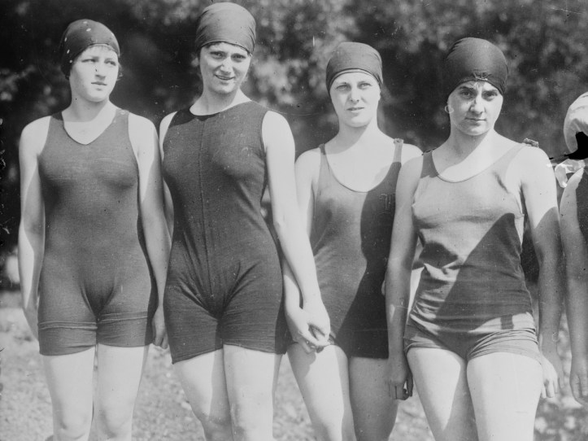

Swimsuits were drastically different than anything that had been seen before. These were carried over from the 1910s of knickers and two-piece tunic but shrunken. The 20s lowered the necklines, shrunk the knickers, and widened the armholes, resulting in a sort of one-piece tank suit. A few years into this decade, knee-length stockings were done away with, and women were able to actually swim now. As the 30'srolled around, women experimented with the fit and the fabric making the necklines similar to their evening gowns, and the suits more form-fitting. At the beginning of the swimsuit revolution, a lot of women were arrested for indecent exposure, but by the 30s two-piece suits made an appearance, thus making a large collection of "one-piece or two-piece styles with either shorts or skirtlike constructions" in the swimsuit market (pg 487).

Survey of Historic Costume 6th edition

<https://fashionhistory.fitnyc.edu/a-history-of-womens-swimwear/>

<https://www.insider.com/evolution-what-swimsuits-look-like-over-the-years-2019-5#women-continued-to-have-swimsuit-regulations-enforced-on-them-in-the-20s-8>

<https://lifestyle.howstuffworks.com/style/fashion/trends-looks/history-of-womens-bathing-suits.htm>

1. Mackinaw - Jalissa Cloward

The Mackinaw jacket, also known as a lumber jacket, is a “sturdy jacket made of heavily fulled wool.” It was a more informal jacket that was mostly used for working and sports. The Mackinaw jacket is still used today, especially within the blue collar community.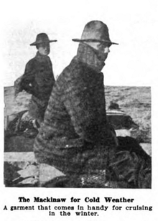

*Survey of Historic Costume* pg. 483

<https://en.wikipedia.org/wiki/Mackinaw_cloth#:~:text=The%20Mackinaw%20jacket%20traces%20its,(Ontario)%2C%20near%20Mackinac>.

<https://www.yourdictionary.com/mackinaw-jacket>

1. Marcel Wave- Marisol Dejesus

Marcel wave is made of deep waves all over the head. The hair technique was created from a heated curling iron. The technique was developed by Marcel Grateau who struggled to find people to practice on. Then he started to offer a free hairstyle to experience the marcel wave. Later the ladies saw how gorgeous the hairstyle was and it got big.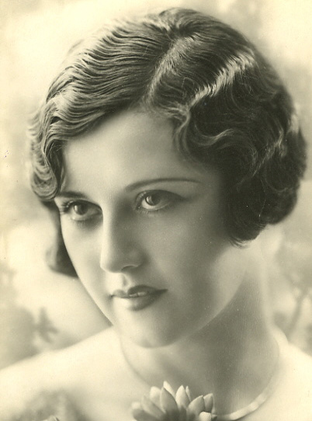

Textbook pg. 469

<https://chicvintagebrides.com/finger-marcel-waves-stylish-hair-of-a-bygone-era/>

<http://www.1920-30.com/fashion/hairstyles/marcel-wave.html>

1. Oxford Bags- Irelynd Preece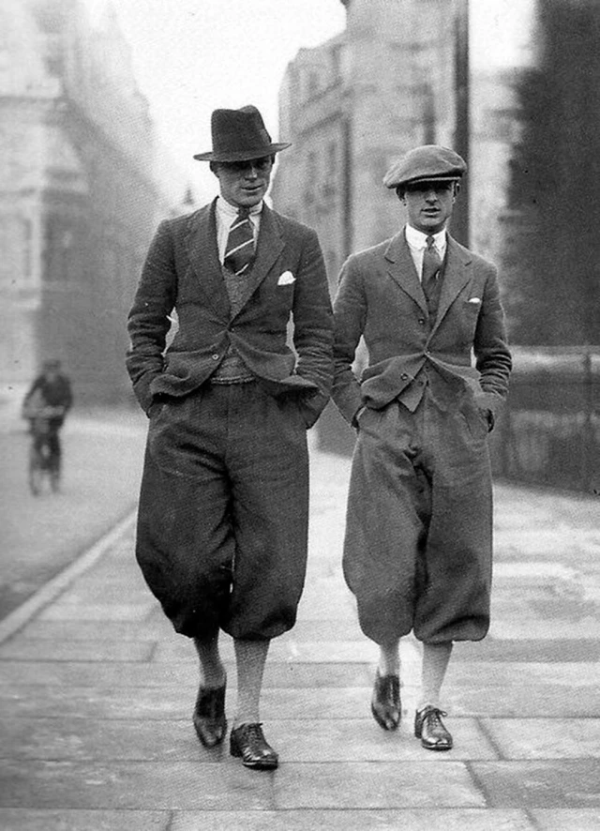

In England, from about the mid 1920s to around the 1950s, Oxford bags were worn over knickers due to the fact that at Oxford students were not allowed to wear knickers to class. So to make it easier to change from long trousers to knickers after school, students wore trousers with excessively wide legs so that they could wear the knickers underneath. The cuffs of the Oxford trousers could have a circumference of about 44 inches!

Sources:

Textbook page 480

<https://en.wikipedia.org/wiki/Oxford_bags>

<https://www.thecrimson.com/article/2019/12/24/this-year-in-fashion-1920/>

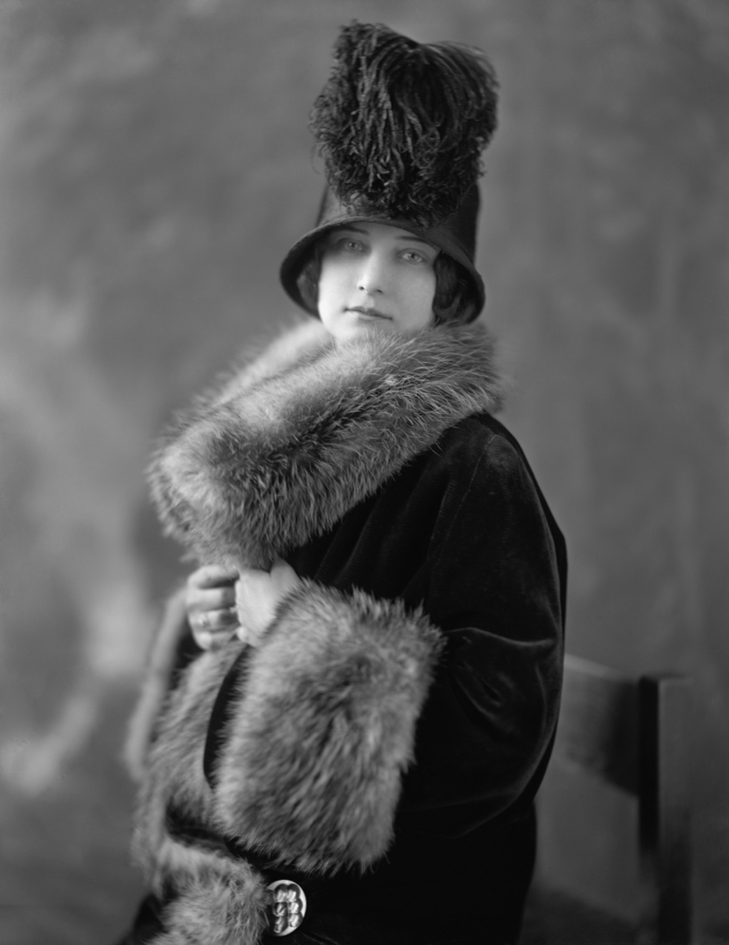

1. Parka Jacket- Hailey Child

The Parka Jacket was big in the 1920’s. The word parka is a Russian word called anorak. It was a hooded coat that was edged with fur and worn outdoors in the cold weather. Parkas were traditionally worn by women.

<https://vintagedancer.com/1920s/womens-coats-of-the-1920s/>

Book

<https://fashionhistory.fitnyc.edu/anorak/>

1. Pork Pie Hat- Savannah Tanner

The pork pie hat became popular in the 1930’s for sportswear. It had a low-crown, and was soft and made from felt. The hat was unique in its capability to be rolled up. The pork pie hat is believed to be named after the Melton Mowbray pork pie, a popular pork-filled pastry. The crust and the crown of the hat resemble one another. Another name the hat goes by is the English pastry hat.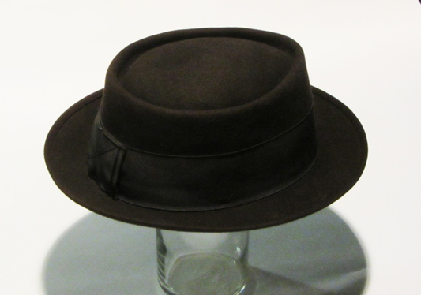

Pg. 486

<http://www.historyofhats.net/hat-history/pork-pie-hat/>

https://www.hatrealm.com/how-did-the-pork-pie-hat-get-its-name/

1. Racoon Coat: Madison Frost

This was a floor length coat made entirely of racoon skins. They were exceptionally popular and usually found worn by college men. When an ad was created called “Doin the Racoon” by George Oslen. THey skyrocketed in popularity among this crowd. Here were they lyrics to the add: 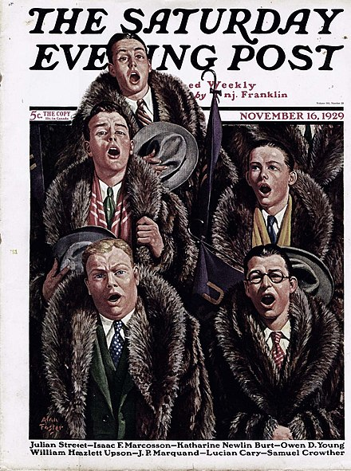

From every college campus comes the cheer: oy-yoy!

The season for the raccoon coat is here, my boy!

Rough guys, tough guys, men of dignity,

Join the raccoon coat fraternity, soon,

To do the raccoon!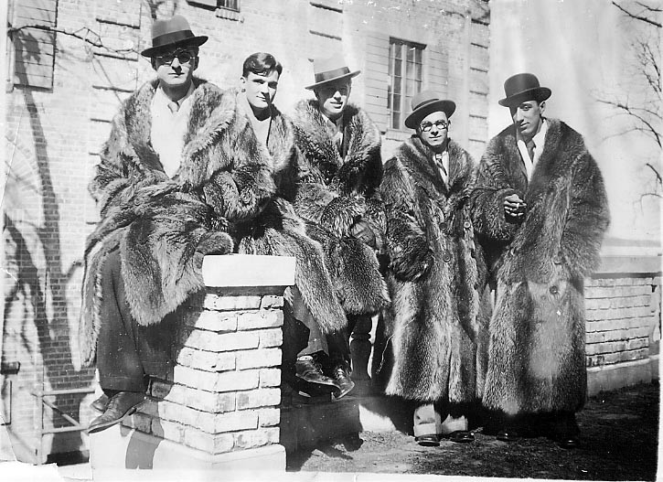

Most cars in the 1920s were open and the first Model T was very expensive. Since these coats had exceptional heat retention skills, they were very common to see during the winters. The coat would become a sign of wealth.

1. Surrealism- Claire Moore

Surrealism is a movement that became popular after world war 1. It was an artistic movement that was based on dreams or unconsciousness. It had a major impact on art, photography, and film. Surrealism artists' main goal was to make the view question or challenge their perception of reality. 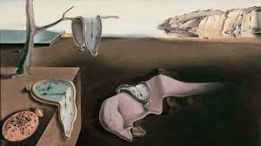

Sources- <https://www.history.com/topics/art-history/surrealism-history>

<https://mymodernmet.com/what-is-surrealism-definition/>

1. T-Shirts lena Kawakami 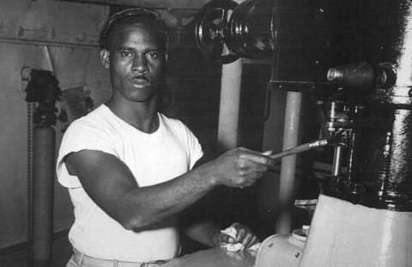

T shirts have a long history, they started out as undergarments that went under more formal clothes, 19th century laborers would cut their jumpsuits in half when it was too hot, then during the Mexican American war the navy began issuing these kinds of shirts as standard undershirts, two movies stars wore t shirts as a regular shirt in 1950 and 1955 and the popularity of wearing it as a garment skyrocketed, it became a symbol of a movement and rebellion because it was in fact an undergarment at the time

1. Teddie- Debbi Wright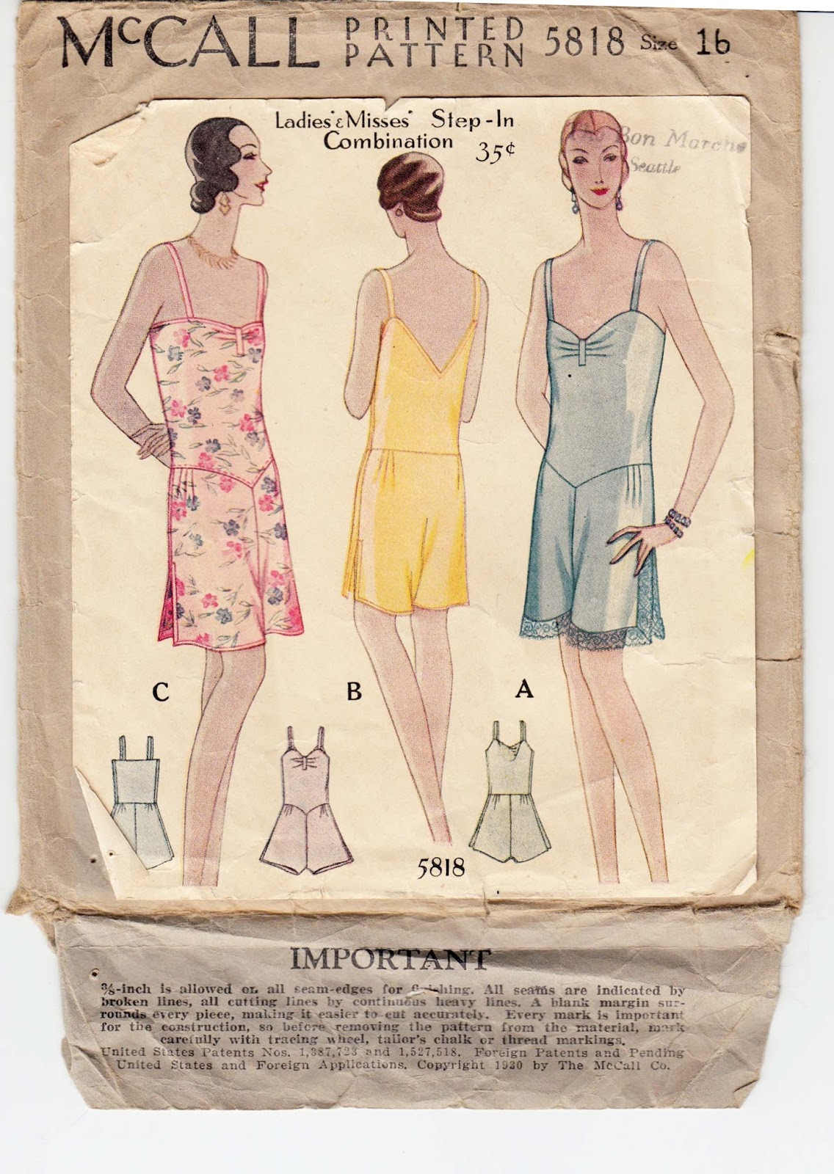

Our textbook describes the teddie as being a combination of camisole and panties. The teddie was also known by other names such as cami-knickers and step-ins. Essentially this was a one piece undergarment.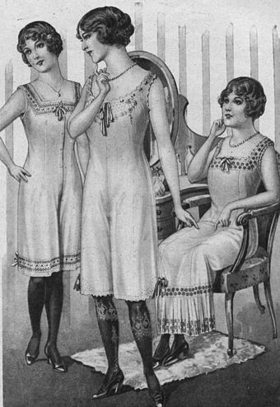

<https://www.wikiwand.com/en/Teddy_(garment)>

<http://afewthreadsloose.blogspot.com/2014/02/my-favorite-1920s-teddies-and-free.html>

Toratora, Phyllis G, and Keith Eubank. *Survey of Historic Costume, 5th Edition*. Berg, 2009

1. Zoot Suits - Alex Clark

The zoot suit was an extreme version of the sack suit in this period. Characterized by the wide, padded shoulders on the jacket along with long, wide lapels and the jacket is usually paired with pegged trousers. The suit itself originated from an African American comedy show during the 1930s then became popularized due to jazz singers. During the wartime zoot suits started to gain a bad name due to bootleg tailors continuing its creation after wartime restrictions were placed. Making many believe the zoot suit to be a waste of resources. This contention with the zoot suit caused problems to occur between the wearers of zoot suits and members of the military. Eventually leading to riots to break out within the Los Angeles area.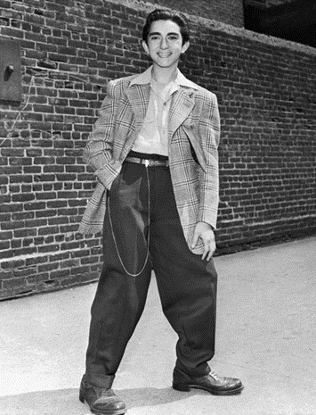

Survey of Historic Costume, Page 482

<https://en.wikipedia.org/wiki/Zoot_suit>

<https://www.history.com/news/what-were-the-zoot-suit-riots>

1. Shingle & Eton Haircuts Ryann Becker 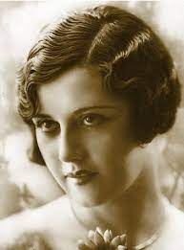

This haircut and style is an iconic 1920s style. It is seen in many motion pictures and was very popular. It was a characteristic of the flapper girls. They showed that women could wear short dresses, have short hair, and break the status quo of older decades. These decades brought more freedom for clothing and hair. Also, these styles could have been worn with a cloche hat. This would practically cover all of their hair. 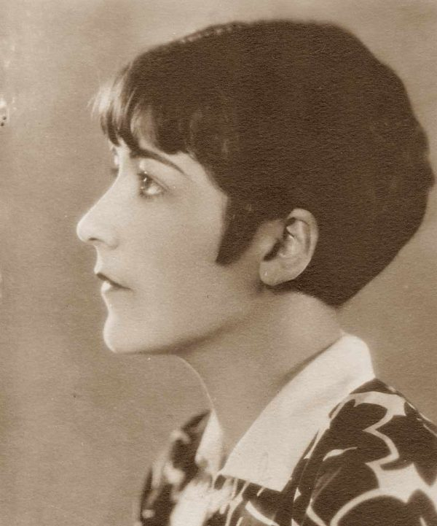

The textbook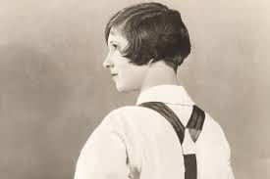

<https://www.beautyanswered.com/what-is-the-eton-crop.htm>

<https://www.1920s-fashion-and-music.com/hairstyles-of-the-1920s.html>

1. Bias cut dresses- Ida Johnson

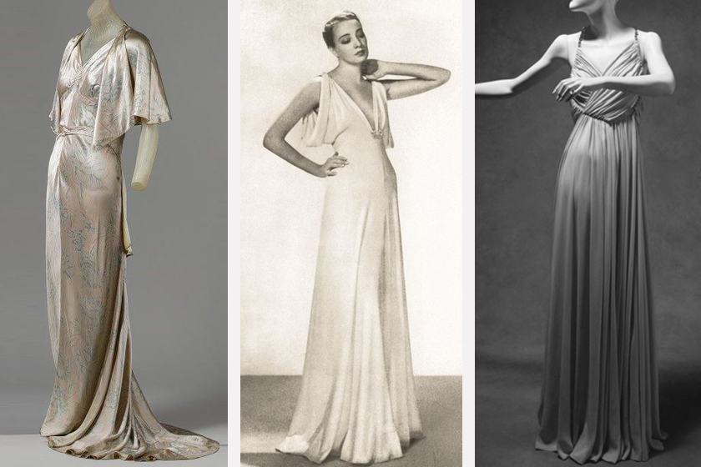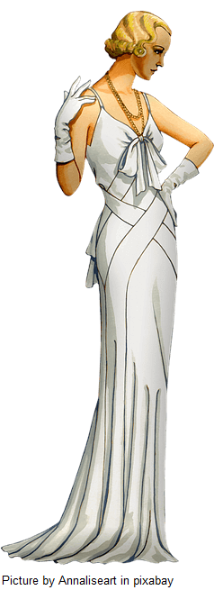

Made famous by Madeleine Vionnet, it is a technique for cutting clothing to utilize the diagonal, allowing for better draping and stretching. These dresses show the lines and curves of the body, leaving little to the imagination. 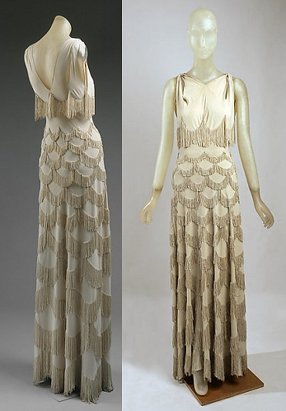

The look was that of ladylike and flowy, made from rayon and silk. Bias cut designs are synonymous with Hollywood glamour during the Depression. “The bias grain is 45 degrees to the warp and weft threads. When we refer to something as being “cut on the bias,” it means that the fabric’s warp and weft threads are positioned at 45 degrees to the major seam lines of the garment”.

<https://whatgrandmawore.wordpress.com/2020/01/25/cutting-the-bias-madeleine-vionnet/>

Pg 456

<https://www.vintagetextile.com/new_page_744.htm>

<https://luxtailor.com/history-of-fashion-1930s-to-1940s-bias-cut-gowns-schiaparelli/>

1. Cami-knicker - Savannah Jeppson

Cami-knickers were an evolution of the undergarment combination. They were also known as step-ins or teddies. It was a combination of the camisole and panties. They were made of lighter, more flowy fabric that allowed for breathability.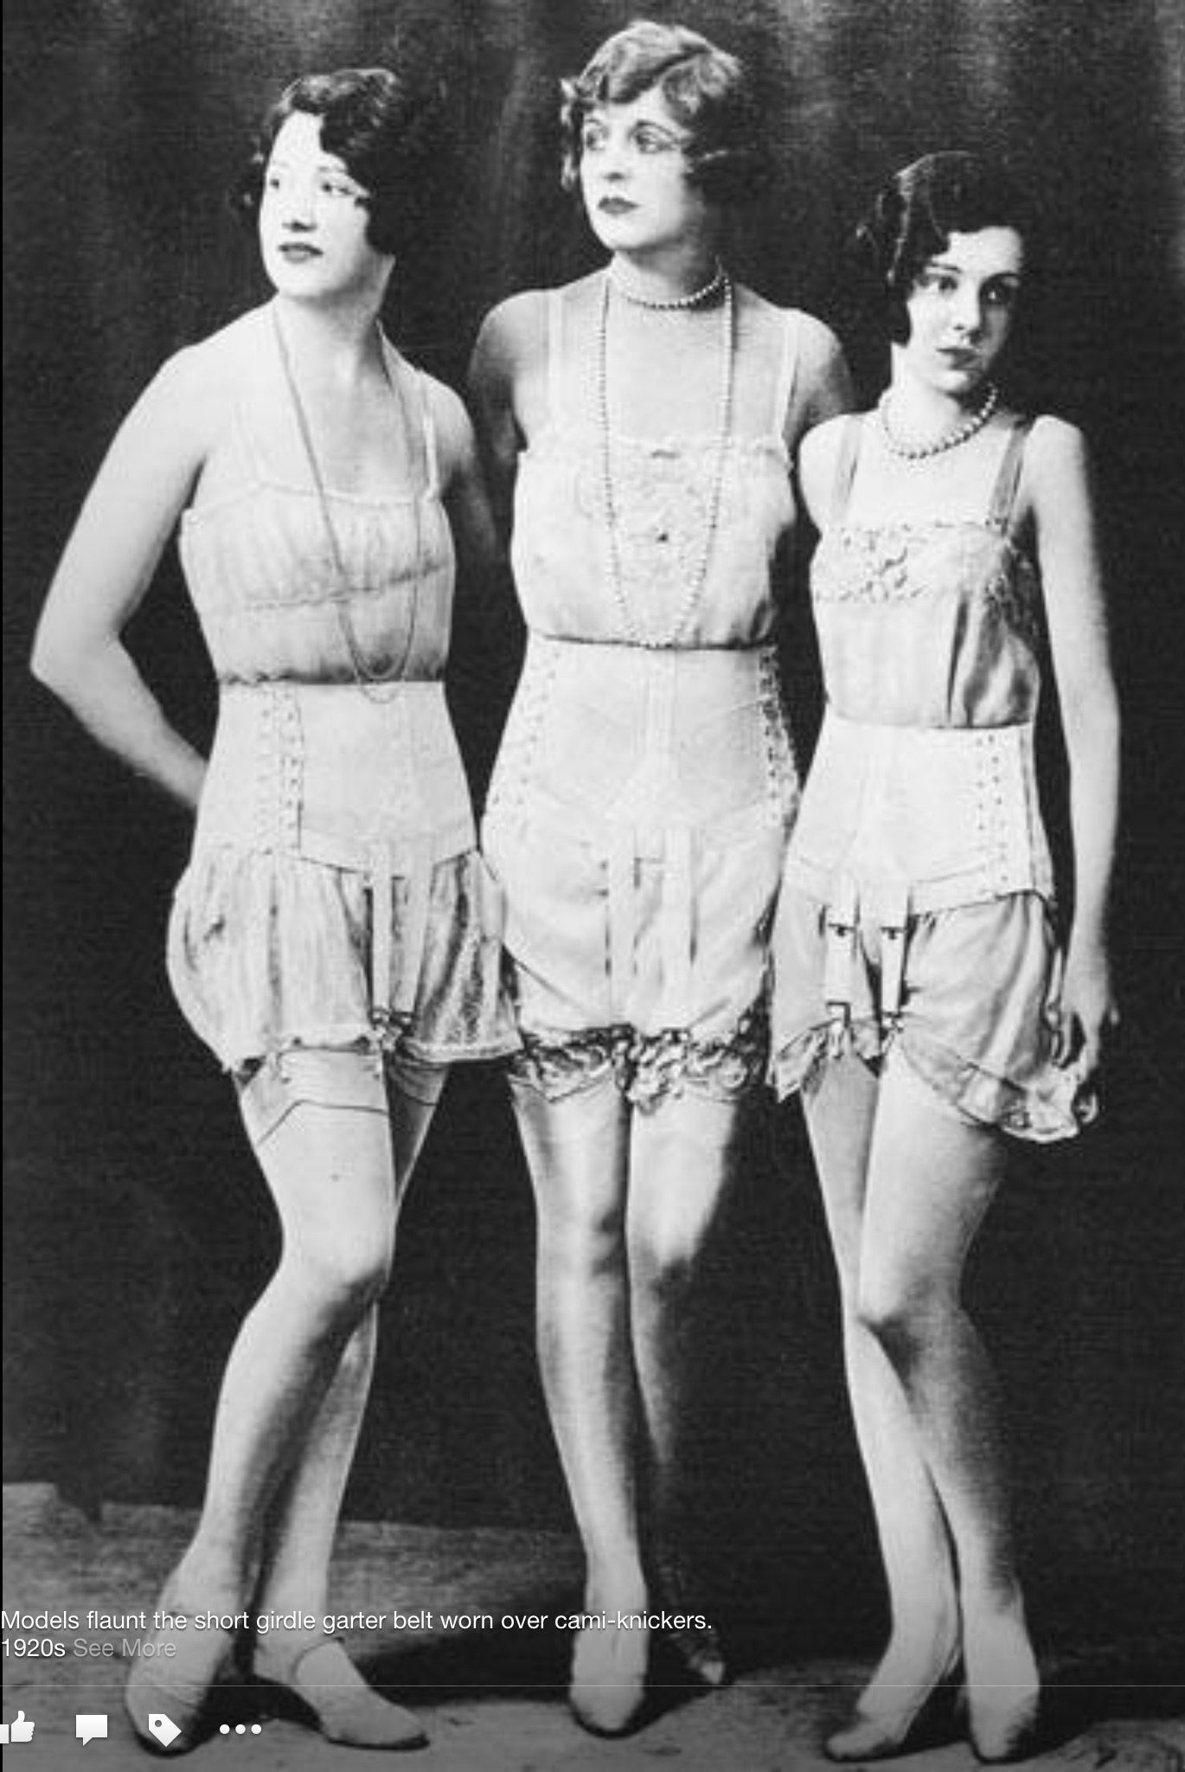

Sources:

The Book : Survey of Historical Fashion

<https://www.sewhistorically.com/dressing-the-1920s-woman-1920s-lingerie/>

<https://fascinationstreetvintage.wordpress.com/2015/07/02/1920s-womens-underwear-pt-1/>

1. Madeleine Vionnet- Anna Ament

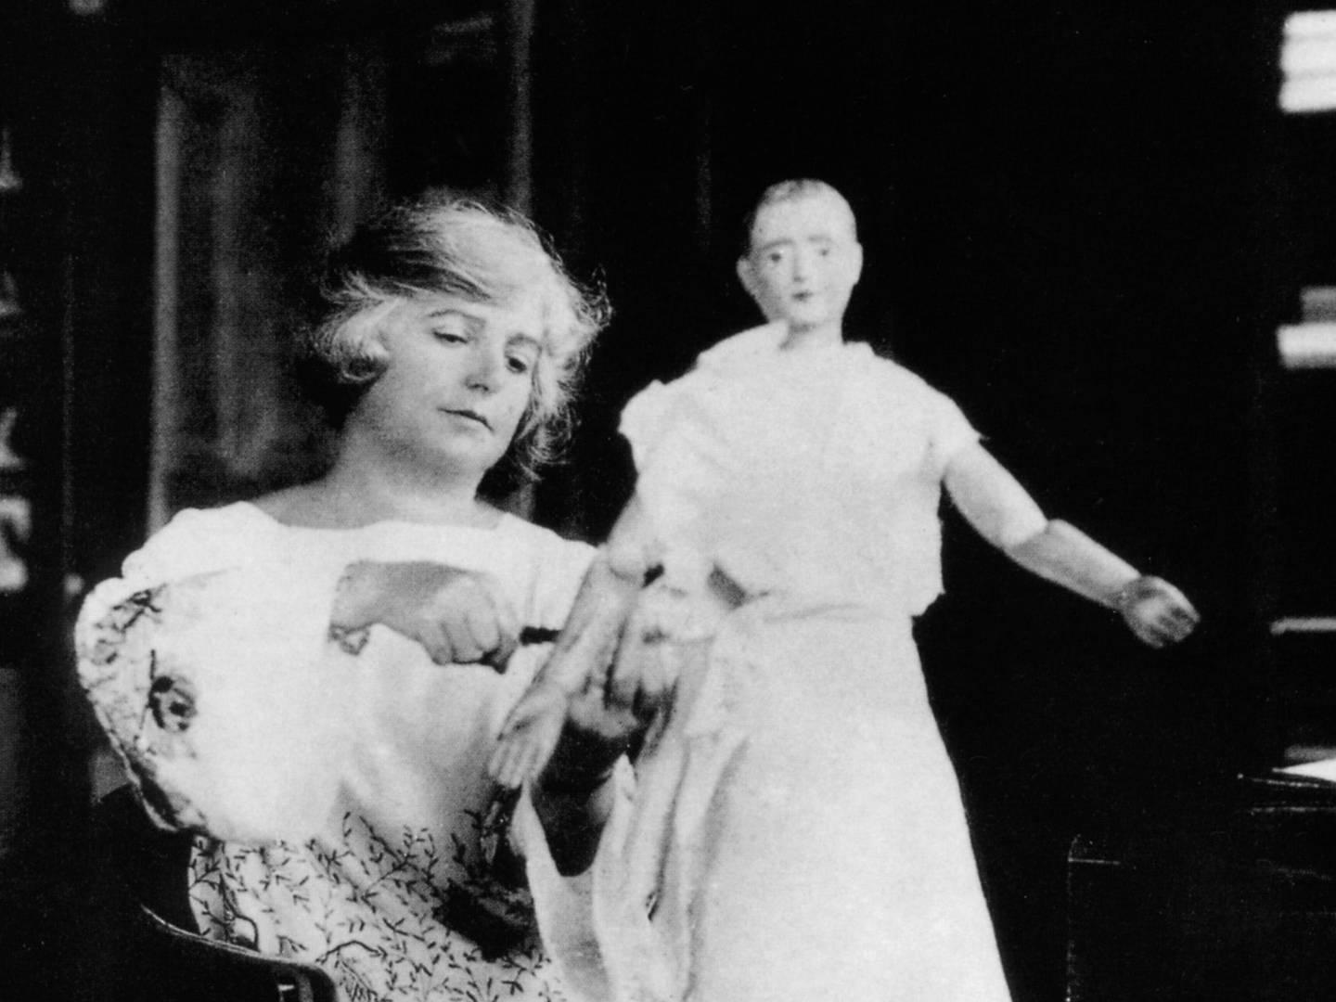

Madeleine Vionnet was a French Fashion designer She is known for branching out to make her own store that became the House of Vionnet. Her prior dress-making experience gave her a leg up in the fashion industry. She was particularly known for the creation of the Bias Cut. She used her various skill-sets to make a variety of styles that were more difficult. Because of the technique she used, she became very popular. Lovers of fashion sought after her designs especially when the Bias Cut. Her designs inspired many other fashion designers to implement different cutting techniques in their designs.

<https://www.vam.ac.uk/articles/madeleine-vionnet-an-introduction>

<https://www.businessoffashion.com/articles/news-analysis/madeleine-vionnet-1876-1975/>

1. Marcel Wave pt. 2- Samantha Hooper

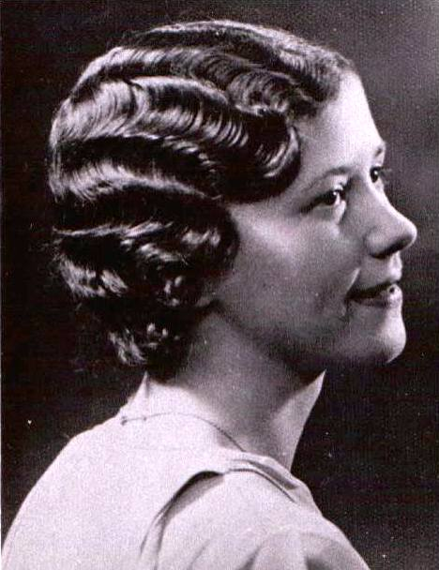

The Marcel Wave was a hairstyle created with a hot iron. While it resembled the finger wave, it was much more easily attainable and more permanent. This hairstyle was most often created on women with the bob cut. This style was created by Marcel Grateau and was incredibly popular during this era. The technique is often referred to as “Marcelling”.

<https://en.wikipedia.org/wiki/Marcelling>

<https://chicvintagebrides.com/finger-marcel-waves-stylish-hair-of-a-bygone-era/>

1. Cloche Hat: Elizabeth Nathan

The 1920’s version of the cloche is iconic. It featured an even more snug fit than its predecessors, and was worn so low over the eyebrows that women walked with their chins up and eyes cast down.

As cloche styles began to grow and change, embellishment began to feature more heavily in the design. Art deco was a heavy influence in all aspects of 1920’s fashion, and hats were no exception. The art style impacted the brim and seam styles of cloche hats, as well as what decorated it. Applique, beads, brooches or feathers were popular, and helped to dress up a hate for more formal occasions. Some versions were made from laces and silks to add glamor, and could be paired with a fancy evening ensemble.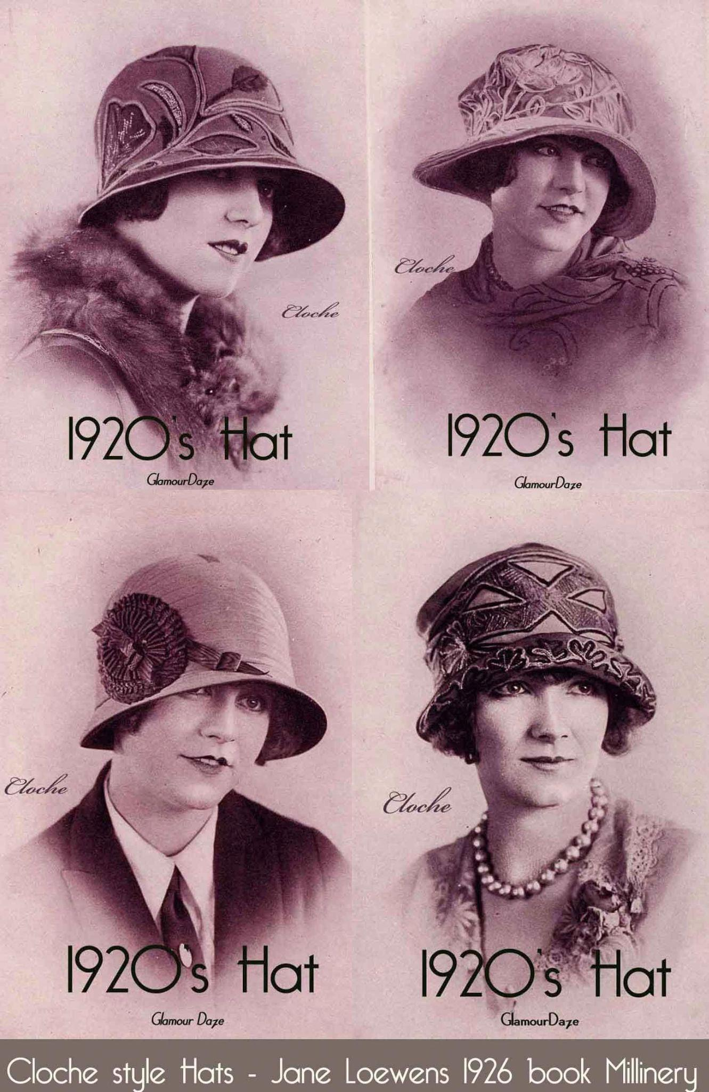

<https://startupfashion.com/fashion-archives-history-cloche-hat/>

<https://fashionhistory.fitnyc.edu/1920-1929/>